April 1, 2014 Press Clips

Print:
- Women’s Wear Daily
Online:
- Women’s Wear Daily
- Fashionista
- GLAM
- Fashion Week Daily/ Daily Front Row
- Fashion Gone Rogue
- PSFK
- Daily Mail U.K.
- IPDA
- 4-Traders
- Fashion Vent
- Fashion Bomb Daily
- HIGH FASHION Magazine
- Paper Specs

WWD
April 1, 2014

Cosmopolitan's May Issue Features Peel-Away Cover
http://www.wwd.com/media-news/fashion-memopad/cosmo-under-the-covers-7626142
COSMO UNDER THE COVERS: Cosmopolitan may be responsible for a relatively new trend in U.S. magazine advertising that could further blur the line between advertising and editorial content — depending on whom you ask.
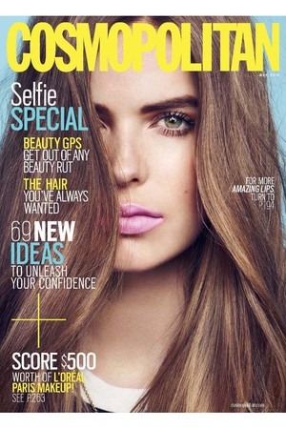
For its May issue, the magazine will feature a pasted-on cover for subscriber copies that is sponsored by L’Oréal. That cover displays model Robyn Lawley with a host of cover lines, including one that advertises a contest to win $500 worth of L’Oréal Paris makeup. The inside of that cover also features a full-page ad for the brand’s “Silkissime” mascara. When that cover is peeled off, the reader will see a second cover, featuring Kaley Cuoco Sweeting of “Big Bang Theory.” Sweeting appears on both the cover of the subscriber issue and the newsstand issue, which goes on sale April 8.
While the model isn’t exactly novel — it’s been used in Europe and some U.S. publications have cover wraps — what differentiates Cosmo’s issue is that the peel-off cover is part of an ad buy. In addition to the inside of the peel-away cover, L’Oréal bought 10 ads in the magazine. Cosmo declined to comment on the financials of the ad buy, but offered that it approached L’Oréal with the cover idea.
“It’s a bit like the white flap on The New Yorker,” Cosmo editor in chief Joanna Coles told WWD. “It gives me twice the real estate to explain what’s in the magazine. It’s not purely an ad. I suspect we’ve unleashed a trend.”
Coles explained that both covers were the product of her editorial team, and that apart from the L’Oréal contest cover line, it’s essentially a second cover.
When asked if the cover could be an example of blurring the lines between editorial and advertising, the editor said, “We follow the guidelines of the MPA [The Association of Magazine Media] very seriously, and Michael Clinton is the chairman of the MPA.”
Clinton, who is also president, marketing and publishing director of Hearst Magazines, was the mastermind behind the beauty-driven campaign, which stretched beyond the pages of Cosmo, and on to other Hearst-owned titles, Coles said. She added that in October, Clinton challenged all of Hearst’s publications to produce ways to drum up beauty advertising dollars.
Many of the titles rose to the challenge, but perhaps none more wholeheartedly than Harper’s Bazaar, which, WWD has learned, will have an all-beauty issue in May, a first for the fashion title.
But back to Cosmo. Vice president and publisher Donna Kalajian Lagani echoed Coles, adding that she believes the magazine has started a movement across the industry. Lagani pointed to two upcoming issues, in which two brands — an undisclosed cosmetics company and a fragrance firm — have separately bought cover wraps of Cosmo. Those issues, which will come out in the fall and in early 2015, will display the word “advertisement” on their covers, Lagani said.
All this still begs the question: If there is indeed a trend emerging, will covers of magazines soon all be wrapped in ads?
“I don’t think this will cause a slippery slope,” Lagani said. “We want to stay within the lines.”

GLAM
April 1, 2014

COSMO MAGAZINE BRINGS PEEL AWAY COVER ADS TO THE NEWSSTAND

http://www.glam.com/cosmo-magazine-brings-peel-away-cover-ads-to-the-newsstand/

The magazine industry appears to be pulling out all the stops when it comes to attracting readers to buy their offerings on the newsstand. Oh, hai, Kanye West and Kim Kardashian on Vogue.

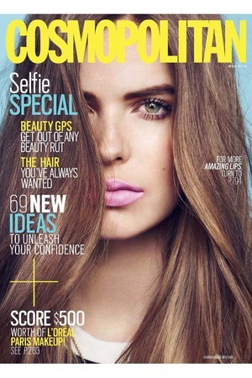

Cosmopolitian is taking a different route to attract readers—a peel away cover! Unlike the peel away cover V magazine did featuring Kate Upton, Cosmo’s May issue features a pasted-on cover for subscribers that is sponsored by L’Oreal advertising a contest to win $500 worth of makeup. When peeled off, the reader will see Cosmo’s newsstand cover with Big Bang Theory’s Kaley Cuoco.

“It’s a bit like the white flap on The New Yorker,” Cosmo’s editor-in-chief Joanna Coles told Women’s Wear Daily. “It gives me twice the real estate to explain what’s in the magazine. It’s not purely an ad. I suspect we’ve unleashed a trend.”

A trend spurred by the fact that Michael Clinton, president and publishing director of Hearst magazines, challenged all of the company’s publications to produce ways to drum of beauty advertising dollars.

Two upcoming issues of Cosmo will be covered by advertisements for an undisclosed cosmetics company and a fragrance firm will be kept under wraps until the fall and early 2015.

The newsstand will tell if this is the next big trend or not—perhaps ads wrapped around our favorite magazines will save the print industry.

Fashionista
April 1, 2014

http://fashionista.com/2014/04/cosmopolitans-sponsored-cover-blurs-the-line-between-editorial-and-advertising/

Cosmopolitan‘s Sponsored Cover Blurs the Line Between Editorial and Advertising

While any opportunity to see Robyn Lawley’s stunning face is usually a welcome one, we’re a little unsure this time around.
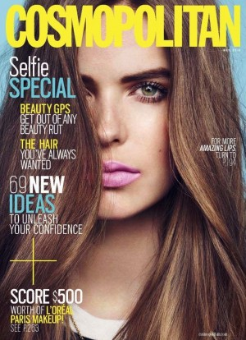

A close-up beauty shot of the plus-size model is featured on the subscriber cover of Cosmo‘s May issue — except it’s not the real cover. It’s a stick-on cover sponsored by L’Oreal, which can be peeled away to reveal the real cover, featuring “The Big Bang Theory” star Kaley Cuoco-Sweeting.

However, unlike most ads and cover wraps you might see around a subscriber copy, it’s not immediately obvious that the cover is an ad. The copy calls out the issue’s contents (“Selfie Special” for instance) just like any cover would, with a mention of a L’Oreal contest at the bottom. “It gives me twice the real estate to explain what’s in the magazine,” Cosmo Editor in Chief Joanna Coles told WWD. “It’s not purely an ad. I suspect we’ve unleashed a trend.”

But is that trend in line with standard print media advertising guidelines? The American Society of Magazine Editors (ASME) puts forth clear principles and guidelines for print publishers to adhere to. The following is first in a list of best practices:

1. Don’t Run Ads on Covers
a. The cover is the editor and publisher’s brand statement. Advertisements should not be printed directly on the cover or spine.
b. Advertisements printed on false covers or cover flaps should not be integrated with editorial content and should not use cover lines similar to those used by the magazine.
c. Advertisements printed on false covers and cover flaps should be labeled as advertising. See “Label Ads That Look Like Edit,” section 3, for directions.
Despite the L’Oreal cover’s seeming violation of that guideline, Coles told WWD that the magazine follows the guidelines of the MPA (which is affiliated with ASME). A rep for ASME and MPA told Fashionista, “As a matter of policy, ASME can’t comment until they have seen the actual magazine and discussed it with the publication’s editors. It wouldn’t be right for us to make any evaluation based solely on today’s story.”

It’s worth noting that the chairman of the MPA, Michael Clinton, is also the marketing president and publishing director of Hearst Magazines. According to WWD, Clinton is also behind a push Hearst is making to generate more ad dollars from beauty companies. As part of that push, Harper’s Bazaar is planning its first beauty-themed issue for May.

That print publishers are going after beauty companies for ad dollars is no surprise. Over the past few years, beauty companies have, unlike most industries, increased ad buys in print publications, so publishers are understandably hoping to get in on that money. But are they doing so at the cost of editorial integrity?

Fashion Week Daily/ Daily Front Row
April 1, 2014

http://www.fashionweekdaily.com/the-fix/article/cosmopolitan-rolls-out-its-first-ever-sponsored-cover

Cosmopolitan Rolls Out Its First-Ever Sponsored Cover

(NEW YORK) Forget subscriber/newsstand covers or very obvious advertiser cover wraps: the next frontier of cover variations just might be peel-away advertiser-sponsored covers, with the editorial cover beneath. Such is the case with the subscriber cover of Cosmopolitan's May issue. Mod Robyn Lawley is featured in a closeup shot on the L'Oreal-sponsored cover, which can be lifted off to reveal the glossy's actual cover gal, Kaley Cuoco-Sweeting of The Big Bang Theory. As for the cover featuring Lawley, a spate of cover lines teasing what's inside the pages of the mag feels very editorial. So does the design: unsurprisingly, as Cosmo's editorial team designed the removable cover.

The tightly-cropped beauty shot of Lawley is quite different from Cosmo's trademark body-flaunting, cropped-at-the-thigh cover fodder, but otherwise it certainly feels like an actual (read: non-sponsored) cover. Muddled lines between editorial and advertising interest, or simply more ways to shout out Cosmo's freshest content? The latter, as far as EIC Joanna Coles is concerned. "It gives me twice the real estate to explain what’s in the magazine,” Coles told WWD, likening Cosmo's peel-off cover to "the white flap on The New Yorker".

L'Oreal is mentioned on the peel-off cover in the bottom lefthand corner, slightly smaller in scale than the other cover lines: "Score $500 worth of L'Oreal Paris Makeup!", which calls out a beauty loot contest inside the mag. The cosmetics behemoth bought the removable cover as well as 10 ads inside the mag; Cosmo purportedly proposed the additional cover concept to L'Oreal. Some media outlets have made a big fuss about whether the peel-off, ad-sponsored cover concept violates ASME's rules. Coles and Cosmopolitan publisher Donna Kalajian Lagani were both unavailable for comment. The issue hits newsstands on April 8.

Fashion Gone Rogue
April 1, 2014

http://www.fashiongonerogue.com/robyn-lawley-lands-cosmopolitan-beauty-supplement-cover/

Robyn Lawley Lands Cosmopolitan Beauty Supplement Cover

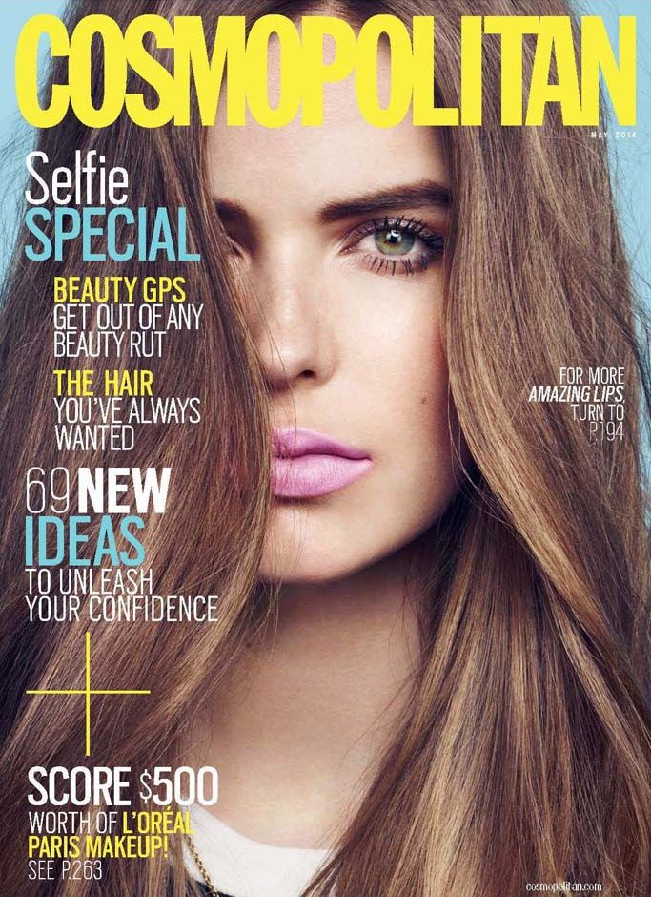

Robyn on Cosmo–After making multiple appearances in the Australian edition of Cosmopolitan, Robyn Lawley lands a supplement cover for the magazine’s US version. Featured on the May issue, Robyn poses on a peel-away cover sponsored by L’Oreal Paris. This follows up the plus size model’s recent turn for a Barneys beauty campaign launched late last year.

PSFK
April 2, 2014

http://www.psfk.com/2014/04/cosmo-peel-off-ad-cover.html#!CxqYF

COSMO’S LATEST COVER IS AN AD THAT PEELS OFF

Cosmopolitan magazine, known for it’s risque articles, is no stranger to controversy. The upcoming May issue, featuring a peel-away cover entirely sponsored by L’Oreal Paris, is bound to get people talking and perhaps not in a good way.

When Cosmo subscribers get their May issue of the magazine, the first thing they will see is a peel-away cover with model Robyn Lawley. It says things like “For more amazing lips, turn to page 94,” referring to the L’Oreal gloss worn by the model, and “Score $500 worth of L’Oreal Paris makeup.” In addition, the inside of the cover shows a full page ad for L’Oreal’s new mascara. And L’Oreal has 10 additional ads throughout the issue.

Behind the peel-away cover is the cover that newspaper stands will sell. It features actress Kaley Cuoco and says ” Kaley Cuoco Sweeting- living the dream,” presumably referring to her recent marriage. The other blurbs on the front of this cover also prelude to the editorial content that awaits readers inside.

While Cosmo is not the first magazine to use a peel-away cover, it is the first to have the peel-away cover be part of an ad buy, and that’s where the heat is coming from. Cosmo Editor-in-chief, Joanna Coles, remains firm that the dual covers are in line with the guidelines of The Association of Magazine Media; Chairman of that association is none other than Michael Clinton, marketing and publishing director of Hearst Magazines (Cosmo is also a Hearst product).

However you feel about the surprising advertising technique, you can be sure Cosmo won’t be the only magazine to use it. In fact, Harper’s Bazaar‘s May issue will be all beauty. Cosmo will also release an undisclosed cosmetics company sponsored peel-away cover this fall, and a fragrance firm sponsored peel-away cover in early 2015.

Cosmo

[h/t] Women’s Wear Daily

Daily Mail UK
April 2, 2014

http://www.dailymail.co.uk/tvshowbiz/article-2594847/Robyn-Lawley-proves-curves-definitely-fashion-celebrates-second-Cosmopolitan-magazine-cover-two-months.html

Now she’s big in America! Robyn Lawley proves curves are definitely in fashion as she celebrates her second Cosmopolitan magazine cover in two months.

Beautiful Australian model Robyn Lawley certainly has a buzz about her at the moment…and it seems the 24 year-old is surprised by it.

Robyn Tweeted, Facebooked and Instagramed the happy news on Tuesday, saying: 'Had no idea, @cosmopolitan USA featured me as a second peel away cover !!! So awesome !!! I can't wait to get an issue'

Her shoot for the May issue of the magazine, marked her first appearance in Cosmopolitan USA, as well as her first full beauty editorial shoot.

On Sunday, the model joked with her social media fans: ‘Hahah I'm getting around the cosmos this month!’

Her comments come after the curvy beauty is also featured in a fashion spread for Cosmopolitan's UK edition.
And earlier in the year, Robyn graced the cover of Australian Cosmopolitan’s March issue.
Not content with just being a model, Robyn also recently launched a plus-size swimwear range, in conjunction with Australian designers Bond-Eye.

The Robyn Lawley Swim Collection was featured at the Curvy Couture Roadshow in Melbourne on Sunday, as part of Virgin Australia's Melbourne Fashion Festival.

Celebrities at the event included David Hasslehoff’s daughter Hayley and former Australian Idol Casey Donovan, who took to the catwalk for a special performance.

Robyn, a New South Wales native who is now based in New York, was in the US when the fashion show took place but seemed to be keeping an eye on things from a far, sharing a photo of the swimwear models backstage, on her Instagram account.

Robyn, is an advocate for dressing beyond a size 10 and has previously spoken out about negative body image, touting on her Facebook page: ‘there is so much more to life then fitting into size 6 jeans. And I'm glad I realised sooner than later :)’

A self-confessed foodie, Robyn regularly posts videos and recipes on her blog Robyn Lawley Eats.

Robyn told news.com.au last year 'When you live in New York you'll eat out most days, if not every day, so I'm going to all these great restaurants,'

‘I just wanted to capture that in a blog and also I love following all the other food blogs. I love food porn. That's what I love, looking at a good photo of a simple dish’ she said.

The success of the her blog has led Robyn to sign a deal with publishers Random House for her a cookbook that she hopes will ignite others with a passion for cooking.

Robyn is also filming a food show in New York for Foxtel.

IPDA
April 2, 2014

http://ipdahome.org/newsstand/?p=32619

Cosmo to Feature Peel-Away Cover on Sub Copies

Hearst’s Cosmopolitan “may be responsible for a relatively new trend in U.S. magazine advertising that could further blur the line between advertising and editorial content, depending on whom you ask,” writes WWD. For its May issue, Cosmo will feature a pasted-on cover on subscriber copies that’s sponsored by L’Oréal. The cover displays model Robyn Lawley with a host of cover lines, including one that advertises a contest to win $500 worth of L’Oréal Paris makeup. The inside of the cover also features a full-page ad for one of the brand’s mascaras. When the cover is peeled off, the reader will see a second cover, featuring Kaley Cuoco Sweeting of “Big Bang Theory.”

Sweeting appears on both the cover of the subscriber issue and the newsstand issue, which goes on sale April 8. While the peel-away cover concept isn’t novel—it’s been used in Europe, and some U.S. publications have cover wraps—what differentiates Cosmo’s issue is that the peel-off cover is part of an ad buy. In addition to the inside of the peel-away cover, L’Oréal bought 10 ads in the magazine. Cosmo declined to comment on the financials of the ad buy, but said that it approached L’Oréal with the cover idea. “It’s a bit like the white flap on The New Yorker,” Cosmo editor-in-chief Joanna Coles asserted to WWD. “It gives me twice the real estate to explain what’s in the magazine. It’s not purely an ad. I suspect we’ve unleashed a trend.”

Coles said that both covers were the product of her editorial team, and maintains that apart from the L’Oréal contest cover line, it’s essentially a second cover. When asked if the cover could be an example of blurring the lines between editorial and advertising, she said, “We follow the guidelines of the MPA [ASME] very seriously, and Michael Clinton is the chairman of the MPA.” Clinton, who is president, marketing and publishing director of Hearst Magazines, was the mastermind behind the beauty-driven campaign, which stretched beyond Cosmo and on to other Hearst-owned titles, Coles said. She added that in October, Clinton challenged all Hearst magazines to produce ways to drum up beauty ad dollars. Will covers of magazines soon all be wrapped in ads? “I don’t think this will cause a slippery slope,” said Cosmo VP and publisher Donna Kalajian Lagani. “We want to stay within the lines.”

WWD

4-Traders
April 2, 2014

http://www.4-traders.com/COSMO-COMMUNICATIONS-CORP-88179/news/Cosmo-Communications--Cosmopolitanlsquos-Sponsored-Cover-Blurs-the-Line-Between-Editorial-and-Adv-18194263/

Cosmo Communications: Cosmopolitan‘s Sponsored Cover Blurs the Line Between Editorial and Advertising

The peel-away subscriber cover

While any opportunity to see Robyn Lawley’s stunning face is usually a welcome one, we’re a little unsure this time around.

A close-up beauty shot of the plus-size model is featured on the subscriber cover of Cosmo‘s May issue — except it’s not the real cover. It’s a stick-on cover sponsored by L’Oreal, which can be peeled away to reveal the real cover, featuring “The Big Bang Theory” star Kaley Cuoco-Sweeting.

However, unlike most ads and cover wraps you might see around a subscriber copy, it’s not immediately obvious that the cover is an ad. The copy calls out the issue’s contents (“Selfie Special” for instance) just like any cover would, with a mention of a L’Oreal contest at the bottom. "It gives me twice the real estate to explain what's in the magazine,” Cosmo Editor in Chief Joanna Coles told WWD. “It's not purely an ad. I suspect we've unleashed a trend."

But is that trend in line with standard print media advertising guidelines? The American Society of Magazine Editors (ASME) puts forth clear principles and guidelines for print publishers to adhere to. The following is first in a list of best practices:
1. Don’t Run Ads on Covers
a. The cover is the editor and publisher's brand statement. Advertisements should not be printed directly on the cover or spine.
b. Advertisements printed on false covers or cover flaps should not be integrated with editorial content and should not use cover lines similar to those used by the magazine.
c. Advertisements printed on false covers and cover flaps should be labeled as advertising. See "Label Ads That Look Like Edit," section 3, for directions.

Despite the L’Oreal cover’s seeming violation of that guideline, Coles told WWD that the magazine follows the guidelines of the MPA (which is affiliated with ASME). A rep for ASME and MPA told Fashionista, “As a matter of policy, ASME can't comment until they have seen the actual magazine and discussed it with the publication's editors. It wouldn't be right for us to make any evaluation based solely on today's story.” It’s worth noting that the chairman of the MPA, Michael Clinton, is also the marketing president and publishing director of Hearst Magazines. According to WWD, Clinton is also behind a push Hearst is making to generate more ad dollars from beauty companies. As part of that push, Harper’s Bazaar is planning its first beauty-themed issue for May.
That print publishers are going after beauty companies for ad dollars is no surprise. Over the past few years, beauty companies have, unlike most industries, increased ad buys in print publications, so publishers are understandably hoping to get in on that money. But are they doing so at the cost of editorial integrity?

(c) 2014 Breaking Media, Inc. All rights reserved. Provided by Syndigate.info, an Albawaba.com company

Fashion Vent
April 2, 2014

http://www.fashionvent.com/robyn-lawley-features-cosmopolitan-beauty-supplement-cover/

Robyn Lawley Features on Cosmopolitan Beauty Supplement Cover

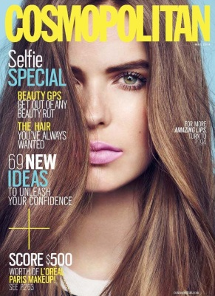
Robyn for Cosmo–Robyn Lawley features on a supplement cover for the magazine’s US version. Gracing the May issue, Robyn poses on a peel-away cover sponsored by L’Oreal Paris.

Fashion Bomb Daily
April 2, 2014

http://fashionbombdaily.com/2014/04/01/fashion-bomb-news-breakdown-106/

The Fashion Bomb News Breakdown: Gisele Bundchen Sings Blondie Cover For H&M Summer Campaign, Cosmo Unveils Product-Placed May 2014 Cover, And Brooklyn Beckham Covers Man About Town Magazine
• Cosmopolitan‘s May 2014 cover could either really annoy readers, or launch a new trend in magazine advertising. This month’s subscriber issue has a peel-away cover sponsored by L’Oreal, featuring model Robyn Lawley. The cover’s got a series of taglines, and opens up into a one-page ad for the brand’s “silkissime” mascara. So, who’s this month’s upstaged cover girl? Big BangTheory‘s Kelly Cuoco Sweeting. Apparently, the sponsored cover was also designed by the Cosmoteam, with the exception of the tagline announcing a L’Oreal contest. “It’s a bit like the white flap on The New Yorker,” editor-in-chief Joanna Coles told WWD. “It gives me twice the real estate to explain what’s in the magazine. It’s not purely an ad. I suspect we’ve unleashed a trend.” Hmm… I kind of hope not. What do you think, guys, are you into seeing more product-placed magazine covers? (WWD)

HIGH FASHION Magazine
April 2, 2014

http://highfashionmagazine.com/news/cosmo-l%E2%80%99oreal-stir-major-controversy-peel-away-ad-cover-39948

It’s no secret that the advertising industry drives commerce, but a new venture between L’Oreal Paris and Cosmopolitan magazine may be pushing the limits of good taste.

For their May 2014 cover (available April 8), the popular publication features a peel-away cover that initially serves as an ad for L’Oreal cosmetics and includes model Robyn Lawley.

Once the first ‘cover’ is removed, “Big Bang Theory” actress Kaley Cuoco appears with the more appropriate front page.

Cosmo editor-in-chief Joanna Coles told WWD, “It’s a bit like the white flap on The New Yorker. It gives me twice the real estate to explain what’s in the magazine. It’s not purely an ad. I suspect we’ve unleashed a trend.”

However, naysayers are calling foul and claiming that Cosmopolitan’s new cover blurs the lines between advertising and journalism.

Still, Coles insists there’s no ethical issues with the decision. “We follow the guidelines of the MPA [The Association of Magazine Media] very seriously, and [Hearst president, marketing and publishing director] Michael Clinton is the chairman of the MPA.”

Paper Specs
April 2, 2014

http://www.paperspecs.com/peel-away-cosmo-cover/

Peel Away Cosmo Cover

Some magazines reward their faithful subscribers with exclusive covers that do away with all the annoying call outs so you can simply bask in the beauty of the cover image itself (hello British movie magazine Empire). Cosmopolitan’s May issue, on the other hand, will club subscribers over the head with a peel-away cover touting the benefits of L’Oreal products. Peeling it off reveals the usual Cosmo cover touting sex and sex, and the usual celebrity whom it’s strongly implied is getting plenty of the first two. (Newsstand readers will be spared the peel-off cover.)

The novelty here isn’t so much the peel-away cover – Women’s Wear Daily tells us this has been used a few times in Europe and the U.S. as part of editorial offerings – as the fact that said cover is one big ad. Cosmo sold L’Oreal 10 magazine ads in addition to the cover.

Hoping that it’s started a profitable trend, Cosmo reveals that a perfume company and a cosmetics firm have also bought similar treatments for issues coming out in the fall and in early 2015.

A brilliant move, in our view. If there’s one sure-fire way to make a peel-away ad cover even more annoying, it’s to layer it with an overpowering scent.

